**Phan Huy Khánh – 22IT.B107 – Lab 4 – Ex 7-2**

1. Run the application in the ex_starts/ch07_ex2 directory. Note that this page displays 3 default values in the three text boxes.

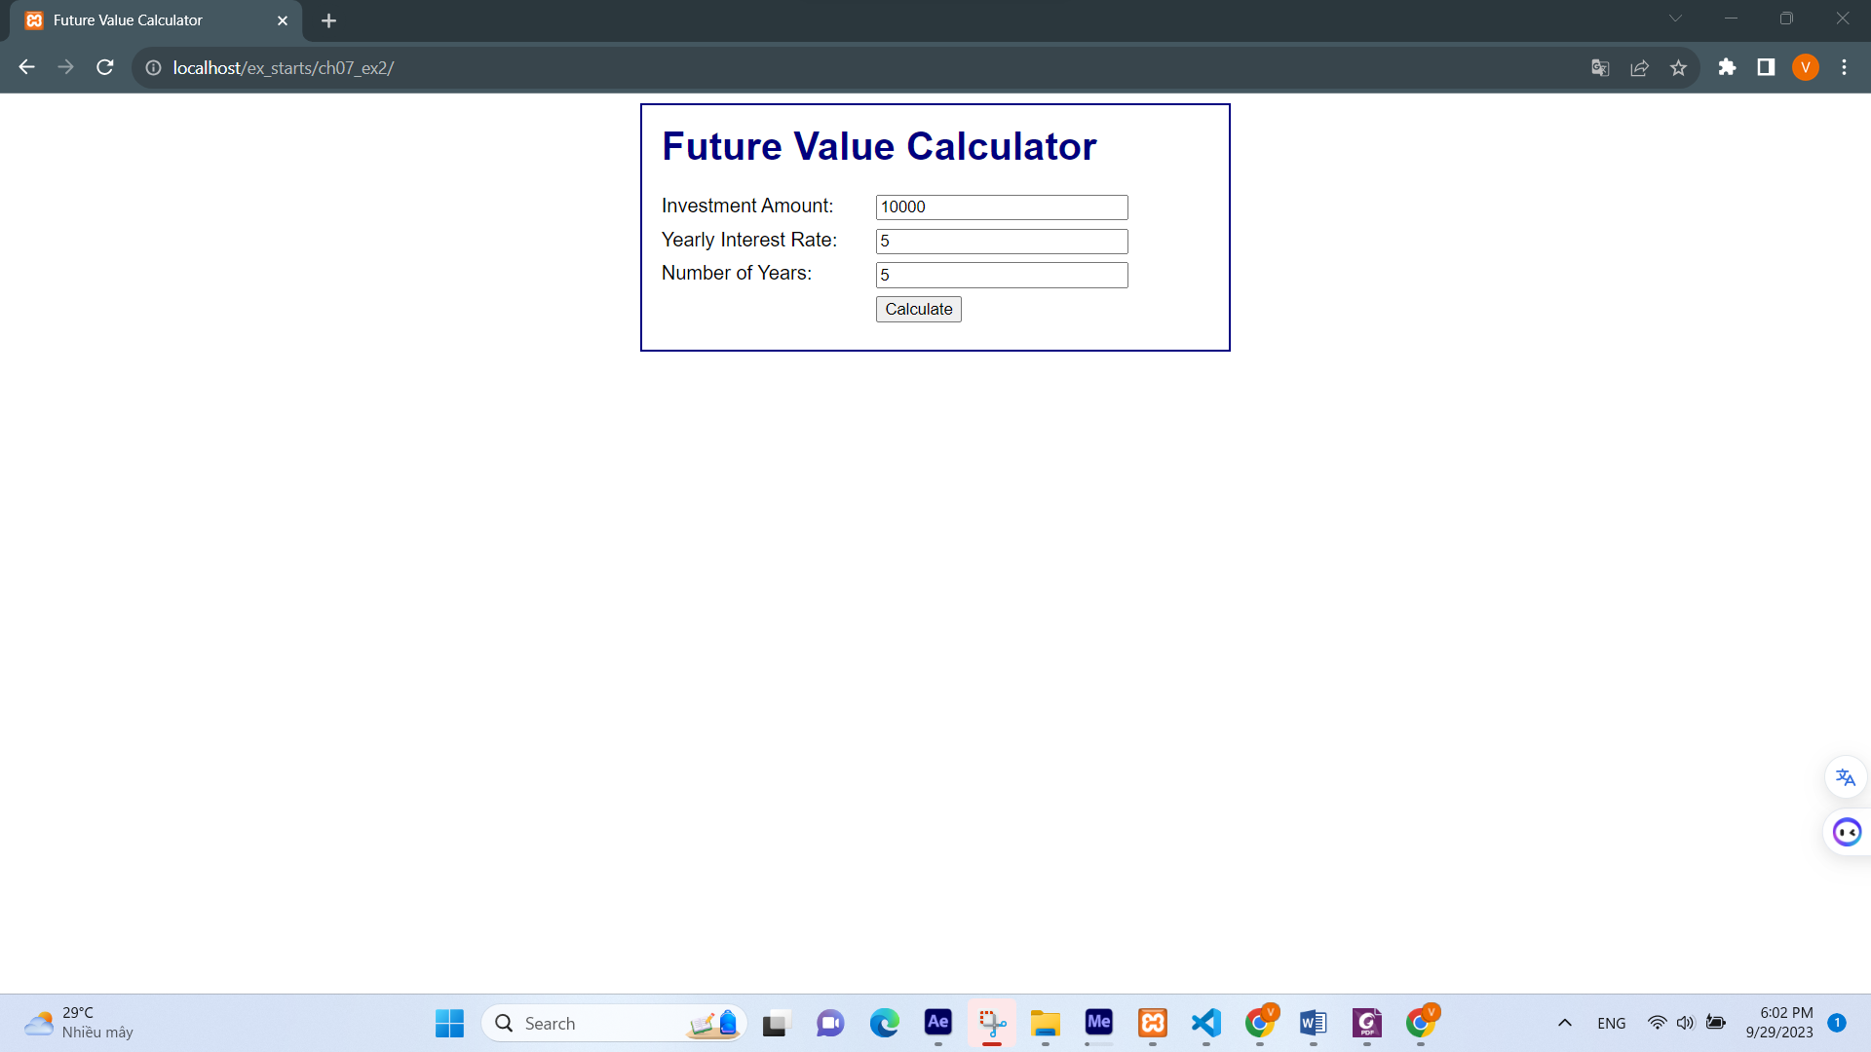

1. Click the calculate button. Note that this displays the correct future value caculation on the second page.

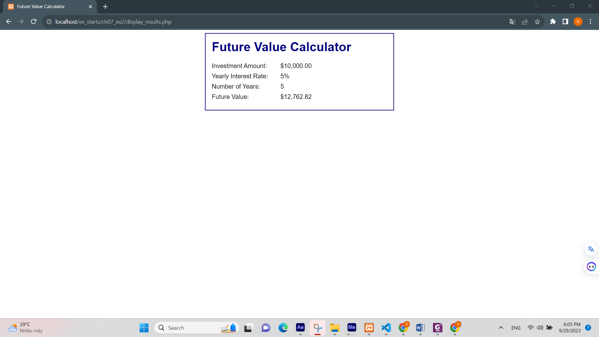

1. Open the index.php and review the code. Note the name that used for the three text boxes.

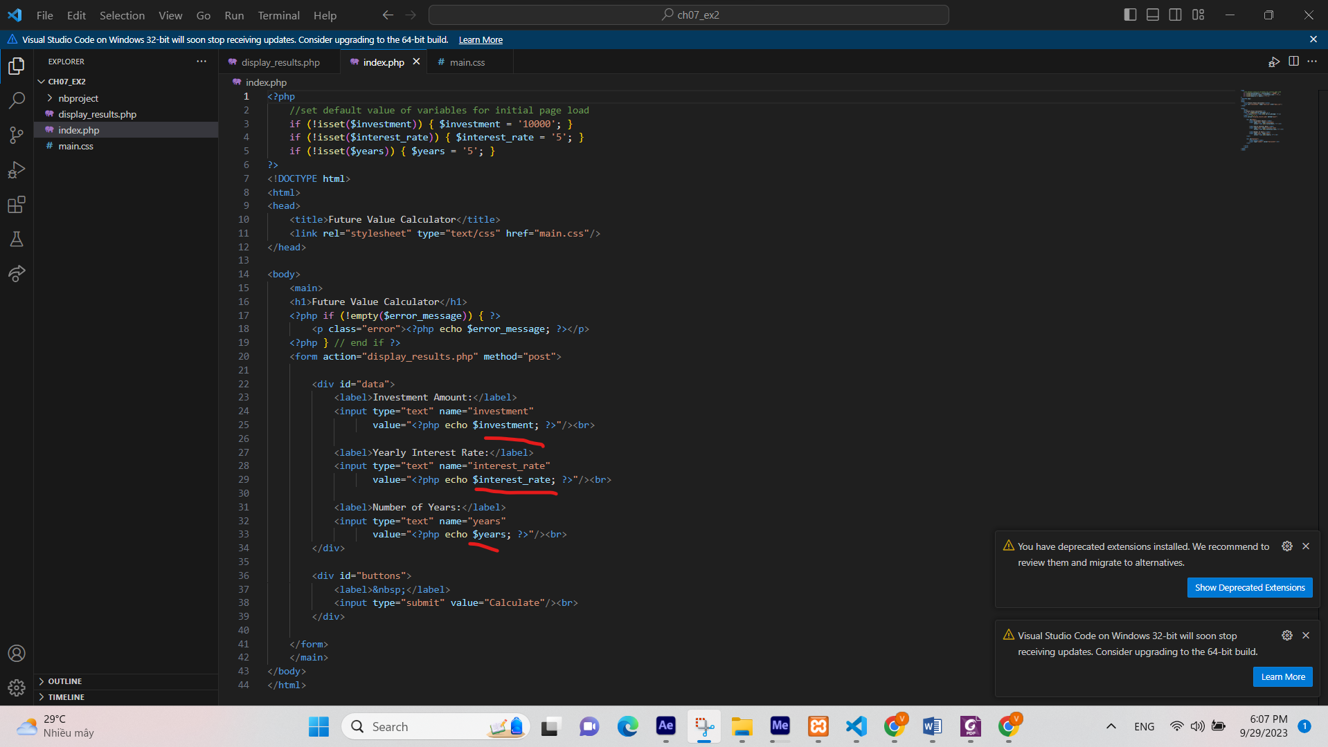

1. Modify the code so it uses drop-down lists instead of text boxes for the first two entries.

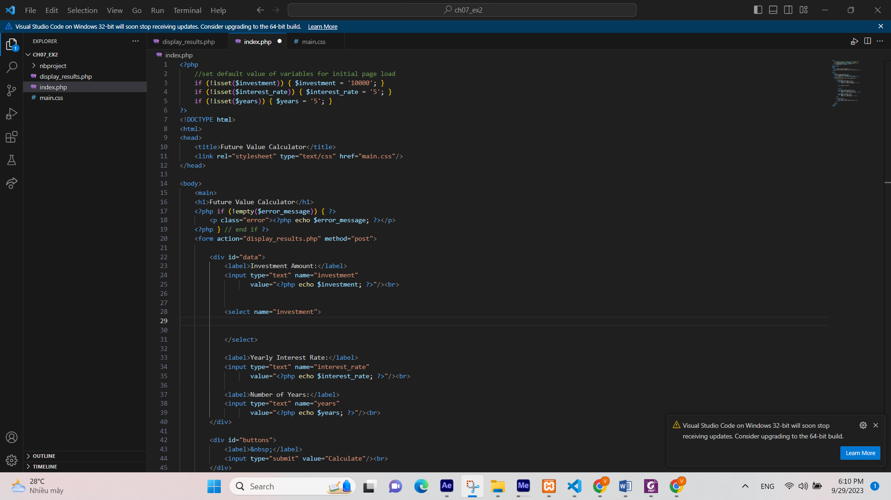

1. For the investment amount, the drop-down list should display value from 10,000 to 50,000 incremented by 5,000. Use for loop.

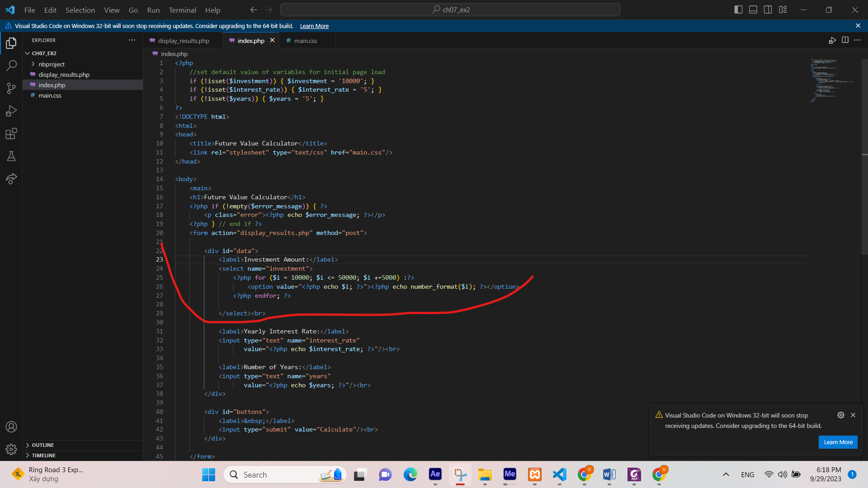

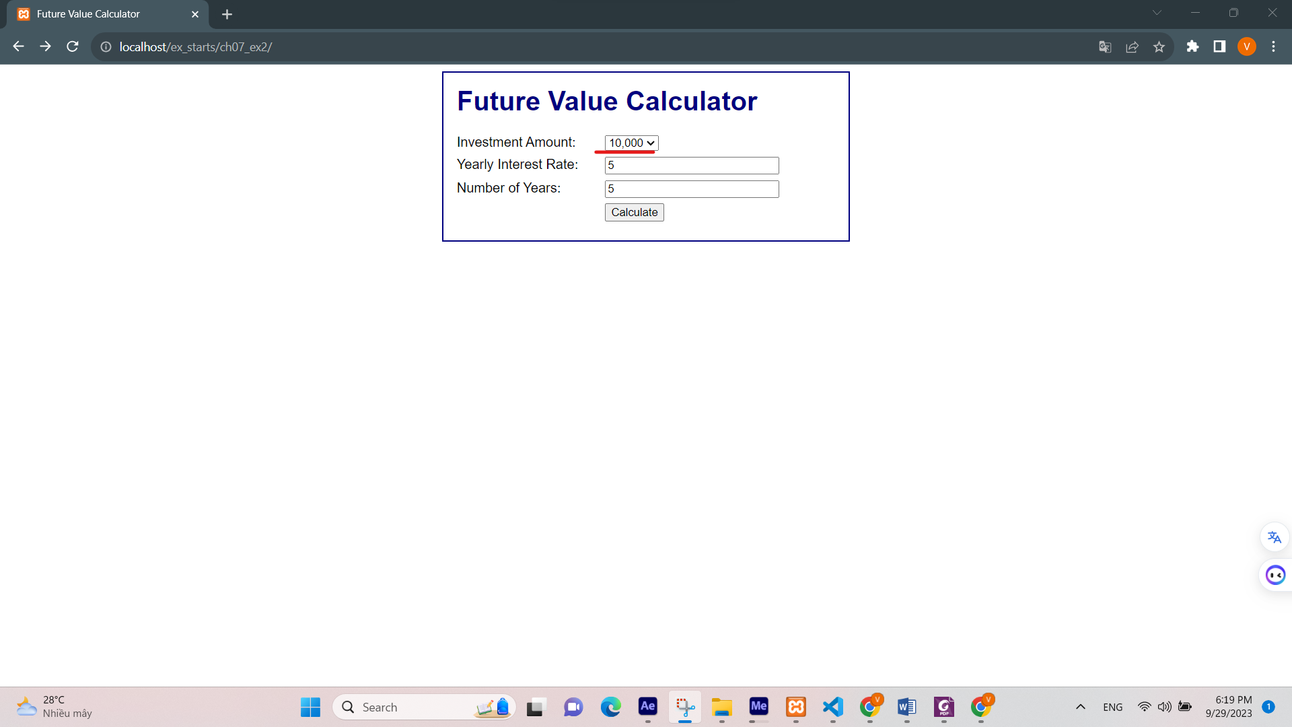

1. For the yearly interest rate, the drop-down list should display values from 4 to 12 incremented by 0.5.

